Kurath's Heraldry Assignment Name:

Part 3-Rough Sketches for 2 different designs.
Use appropriate tinctures, ordinaries and charges. Write the meanings of the different aspects and what significance they have to you.

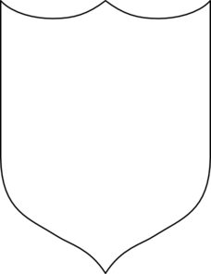

Tincture:____________________________
Divisions:___________________________
Charges:____________________________
Significance to you: _________________________________________________
________________________________________________________________________________________________________________________________________________________________________________________________________________________________________________________________________

Tincture:____________________________
Divisions:___________________________
Charges:____________________________
Significance to you: _________________________________________________
________________________________________________________________________________________________________________________________________________________________________________________________________________________________________________________________________________________________________________________________________________________________________________________________________________________________________________________________________________________________________________________________________________

