Mr. Kurath's Heraldry Assignment Name: Click here to enter text.

Complete the following research on Heraldry and then hand it in on the Class Assignment website.

Definitions
Define or describe the following:
- Heraldry:Click here to enter text.
- Tincture: Click here to enter text.
- Charge: Click here to enter text.
- Motto: Click here to enter text.
- Divisions of Field/Ordinaries: Click here to enter text.

Elements
List the 5 elements that make up a Coat of Arms.
Click here to enter text.

Colors and meaning
What color are the following and what is it's meaning?

- Azure enter color
Meaning: Click here to enter text.

- Purpure Click here to enter text.
Meaning: Click here to enter text.

- Gules: Click here to enter text.
Meaning: Click here to enter text.

- Sable: Click here to enter text.
Meaning: Click here to enter text.

- Vert: Click here to enter text.
Meaning: Click here to enter text.

Symbols
Give me the names and meanings of 10 different heraldic symbols that are of interest to you for your shield design.

- Click here to enter text.
- Click here to enter text.
- Click here to enter text.
- Click here to enter text.
- Click here to enter text.
- Click here to enter text.
- Click here to enter text.
- Click here to enter text.
- Click here to enter text.
- Click here to enter text.

Practice
For each of these shields name and describe the meaning of the following:

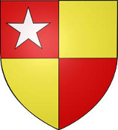
Tincture: Click here to enter text.

Divisions/Ordinaries: Click here to enter text.

Charge: Click here to enter text.

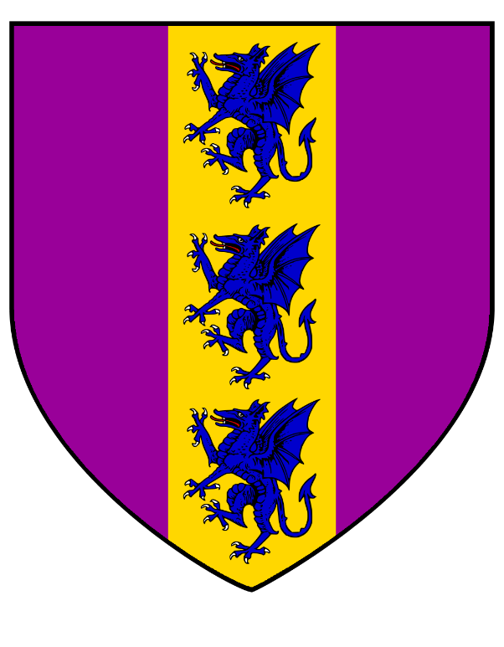
Tincture: Click here to enter text.

Divisions/Ordinaries: Click here to enter text.

Charge: Click here to enter text.

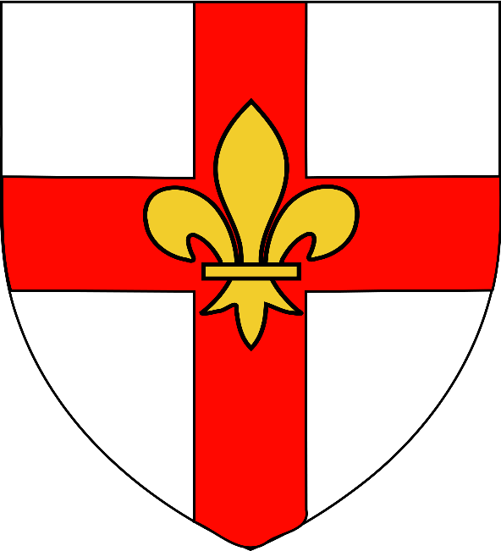
Tincture: Click here to enter text.

Divisions/Ordinaries: Click here to enter text.

Charge: Click here to enter text.

