Feedback Sandwich
Instructions: During the Book Trailer presentations, you must fill out one feedback sandwich sheet.

Student:_______________________________________ ___ Date:_______________________
Project Name: _____________________________________
Feedback Sandwich filled out by: ______________________

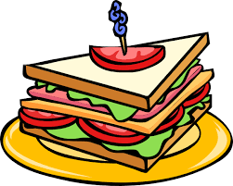 | Top Crust (a compliment for work well done)
 | Filling (suggestions for gourmet quality work)
 | Bottom Crust (a concluding compliment for work done well)

