Book Trailer Planning Template
Name of Book Trailer:_____________________________________________ Producer Name:______________________________
Hints and Tips:
- Look for the "hook". Read the back of the book. Is there a sentence that grabs your attention? What about the first few paragraphs of the book?
- Think critically about the book…what aspects do you want to highlight?
- What is the book's theme?
- Who are the major characters?
- What happens in the plot?
- Is the conflict internal or external?
- From what point of view is the story told?
- Do not give away too much or reveal the climax of the storyline.
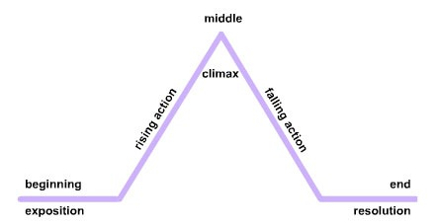

Words: Write one sentence that tells about the story and will make someone want to read it:______________________________________________________
______________________________________________________________________________________________________________________________________________________________________________________________________________________________________________________________________
Story Highlights: What aspect of the story will you focus on?
Hints and Tips:
- The event should be near the beginning of the book
- The event should tell about the problem
- The event should show the characters
- The event should give a hint to what will happen next
Exciting scenes? Suspense?
______________________________________________________________________________
______________________________________________________________________________

Images: List the important visual elements that will be included, like who (characters) and what (setting/accessories). This will help you create the Storyboard.
___________________________________________________________________________________________________________________________________
Sound Effects/Music: ________________________________________________________________________________________________________________
Pacing: How will pacing be used? To draw interest, create suspense, show action? Timing should be effective 7 efficient.
___________________________________________________________________________________________________________________________________
Mood: What kind of mood do you want to create? Sadness? Suspense? How will the sound, pacing and words help?
___________________________________________________________________________________________________________________________________

